T.C.
İSTANBUL YENİ YÜZYIL UNIVERSITY
INSTITUTE OF SOCIAL SCIENCES
………………………………………. DEPARTMENT
…………………………………….. PROGRAMME



WRITE THE GRADUATION PROJECT’S NAME HERE
NON-THESIS MASTER’S DEGREE
GRADUATION PROJECT

NAME SURNAME
STUDENT NO

İSTANBUL, JANUARY 20…

T.C.
İSTANBUL YENİ YÜZYIL UNIVERSITY
INSTITUTE OF SOCIAL SCIENCES
……………………………………… DEPARTMENT
…………………………………….. PROGRAMME
WRITE THE GRADUATION PROJECT’S NAME HERE
NON-THESIS MASTER’S DEGREE
GRADUATION PROJECT

NAME SURNAME
STUDENT NO
ORCID NO: XXXX-XXXX-XXXX-XXXX

SUPERVISOR
PROF. DR. NAME SURNAME

İSTANBUL, JANUARY 20….


MASTERS DEGREE (NO THESIS) GRADUATION PROJECTCONFIRMATION

DOCUMENT

SOSYAL BİLİMLER ENSTİTÜSÜ MÜDÜRLÜĞÜNE
Öğrenci Adı, Soyadı:
Numarası :
TC Kimlik No :...........................................................................................
Telefon: : ………………………………………………………..
E-posta:: .........................................................@..............................
Ders Durumu:
Tamamlandı
Tamamlanmadı
PROJE KONUSU
………………………………………………………………………………………………………………………………………………………………………………………………………..

PROJE DEĞERLENDİRME
Danışmanlığı tarafımca yürütülen ve yukarıda ilgili bilgileri yer alan mezuniyet projesi tarafımca değerlendirilmiş ve Başarılı /düzeltilmesi / Başarısız hususunda kanaat getirilmiştir.
Proje Danışmanının Adı-Soyadı/İmzası
........./........./20....

T.C.
İSTANBUL YENİ YÜZYIL UNIVERSITY
INSTITUTE OF SOCIAL SCIENCES
……………………………………………………………

NON-THESIS MA PROGRAMME

ETHICAL STATEMENT
I prepared my project following the thesis writing rules of the Institute of Social Sciences at Istanbul Yeni Yüzyıl University, and I hereby declare that;
- I have obtained the data, information, and documents provided within the thesis according to academic and ethical rules,
- I have submitted all information, documents, evaluations, and results under the requirements of scientific ethics and moral rules,
- I have cited all works that I have used in the project by appropriately referring to my sources,
- I have not made any changes to the data used,
- I declare that the work I present is original, and
if found otherwise, I accept all loss of rights that may occur.
…/…/ 20……
NAME SURNAME

PREFACE

(This is the section where the purpose, importance, the scope of the thesis, as well as explanations such as acknowledgments to certain people and/or organizations who contributed materially and spiritually to the preparation of the thesis, is included. This section should not be more than one page.)

İSTANBUL, 20…. NAME SURNAME

ÖZET
PROJE ADINI BU KISIMA YAZINIZ
ADI SOYADI
ORC-ID: 0000-000X-XXXX-XXXX
Lorem İpsum, dizgi ve baskı endüstrisinde kullanılan mıgır metinlerdir. Lorem İpsum, adı bilinmeyen bir matbaacının bir hurufat numune kitabı oluşturmak üzere bir yazı galerisini alarak karıştırdığı 1500'lerden beri endüstri standardı sahte metinler olarak kullanılmıştır. Beşyüz yıl boyunca varlığını sürdürmekle kalmamış, aynı zamanda pek değişmeden elektronik dizgiye de sıçramıştır. 1960'larda Lorem Ipsum pasajları da içeren Letraset yapraklarının yayınlanması ile ve yakın zamanda Aldus PageMaker gibi Lorem Ipsum sürümleri içeren masaüstü yayıncılık yazılımları ile popüler olmuştur.

Anahtar Kelimeler: Lipsum, Lorem İpsum, Lorem İpsum Kullanımı.

ABSTRACT
THE TITLE OF THE PROJECT
NAME SURNAME
ORC-ID: 0000-000X-XXXX-XXXX
Lorem Ipsum is the dummying text of the printing and typesetting industry. Lorem Ipsum has been the industry’s standard dummy text since the 1500s when an unknown printer took a galley of type and scrambled it to make a type specimen book. It has survived five centuries, and the leap into electronic typesetting remains unchanged. It was popularised in the 1960s with the release of Letraset sheets containing Lorem Ipsum passages and, more recently, desktop publishing software like Aldus PageMaker, including versions of Lorem Ipsum.

Keywords: Lipsum, Lorem Ipsum, Usage of Lorem Ipsum. (3-5 keywords)

TABLE OF CONTENTS
Page No.
PROJECT CONFIRMATION DOCUMENT i
ETHICAL STATEMENT ii
PREFACE iii
ÖZET iv
ABSTRACT v
TABLE OF CONTENTS vi
LIST OF TABLES vii
LIST OF FIGURES viii
LIST OF ABBREVIATIONS ix
INTRODUCTION 1
1. HISTORY OF LOREM İPSUM 2
1.1. De finibus Bonorum Et Malorum, written by Cicero in 45 B.C 2
2. THE USAGE OF LOREM IPSUM 3
2.1. Usage in Printing Press 3
2.1.2. Quotations 4
CONCLUSION AND PROPOSALS 5
BIBLIOGRAPHY 6
APPENDIX 7
LIST OF TABLES
Page No.
Table 2.1. Product Properties 4

LIST OF FIGURES
Page No.
Figure 2.1.Distribution of Domestic Appliances 3

LIST OF ABBREVIATIONS
BC: Before Christ
etc.: et cetera
GDP: Gross Domestic Product
GNP: Gross National Product
ICOC: Istanbul Chamber of Commerce
IMF: International Monetary Fund
kWh: kilowatt per hour
UN: United Nations
USA: United States of America

INTRODUCTION
Contrary to popular belief, Lorem Ipsum is not simply random text. It has roots in a piece of classical Latin literature from 45 BC, making it over 2000 years old. Richard McClintock, a Latin professor at Hampden-Sydney College in Virginia, looked up one of the more obscure Latin words, consectetur, from a Lorem Ipsum passage and, going through the cites of the word in classical literature, discovered the indisputable source. Lorem Ipsum comes from sections 1.10.32 and 1.10.33 of de Finibus Bonorum et Malorum (“On the ends of good and evil”) by Cicero, written in 45 BC. This book is a treatise on the theory of ethics, which was very popular during the Renaissance. The first line of Lorem Ipsum, “Lorem ipsum dolor sit amet,” comes from a line in section 1.10.32.
The standard chunk of Lorem Ipsum used since the 1500s is reproduced below for those interested. In addition, sections 1.10.32 and 1.10.33 from “de Finibus Bonorum et Malorum” by Cicero are also reproduced in their exact original form, accompanied by English versions from the 1914 translation by H. Rackham.

HISTORY OF LOREM IPSUM
“Lorem ipsum dolor sit amet,” consectetur adipiscing elit, sed do eiusmod tempor incididunt ut labore et dolore magna aliqua. Ut enim ad minim veniam, quis nostrud exercitation ullamco laboris nisi ut aliquip ex ea commodo consequat. Duis aute irure dolor in reprehenderit in voluptate velit esse cillum dolore eu fugiat nulla pariatur. Excepteur sint occaecat cupidatat non proident, sunt in culpa qui officia deserunt mollit anim id est laborum.

Finibus Bonorum Et Malorum, written by Cicero in 45 B.C.
Sed ut perspiciatis unde omnis iste natus error sit voluptatem accusantium doloremque laudantium, totam rem aperiam, eaque ipsa quae ab illo inventore veritatis et quasi architecto beatae vitae dicta sunt explicabo. Nemo enim ipsam voluptatem quia voluptas sit aspernatur aut odit aut fugit, sed quia consequuntur magni dolores eos qui ratione voluptatem sequi nesciunt. Neque porro quisquam est, qui dolorem ipsum quia dolor sit amet, consectetur, adipisci velit, sed quia non numquam eius modi tempora incidunt ut labore et dolore magnam aliquam quaerat voluptatem. “Ut enim ad minima veniam, quis nostrum exercitationem ullam corporis suscipit laboriosam, nisi ut aliquid ex ea commodi consequatur? Quis autem vel eum iure reprehenderit qui in ea voluptate velit esse quam nihil molestiae consequatur, vel illum qui dolorem eum fugiat quo voluptas nulla pariatur”.
Please make sure that the section break pages are not too blank. Also, make sure that the tables are on the same page, that the subject, section, and preliminary titles are included in a new page, and that there are no less than 3 lines at the end and beginning of the page.
Before switching to a new “preliminary title,” you should click “LayoutBreaksNext Page” and add a “Section Break (Next Page).” If it is not appropriately done, the preliminary title will not show up as 72 pt from the top. In doing so, you will also have obeyed the rule that the “preliminary pages should begin from a new page.”

USAGE OF LOREM IPSUM

Usage in Printing Press
Lorem ipsum dolor sit amet, consectetur adipiscing elit. Maecenas vitae posuere velit. Praesent tristique lacus at orci laoreet, vitae faucibus odio rhoncus. Quisque rutrum diam diam, in cursus arcu porta vel. Suspendisse pulvinar elementum orci, eu condimentum nibh ornare eu. Proin lacinia, turpis in efficitur maximus, lorem libero vehicula nibh, vitae laoreet nisi tortor at quam. Quisque porta lectus dolor, sed varius leo molestie eget. Maecenas id lorem in justo semper malesuada. Cras aliquet urna id lorem egestas, quis dictum elit aliquam. Morbi vel risus vestibulum dolor commodo viverra id quis sem. Suspendisse sed tempor tellus. Quisque quam urna, pharetra ac porta sed, mattis id orci. Praesent tellus lorem, venenatis nec blandit sit amet, tincidunt vel dolor. Mauris nisl odio, congue sit amet lectus quis, semper molestie ipsum. Vestibulum ligula mi, ullamcorper eget faucibus ut, porttitor commodo arcu.

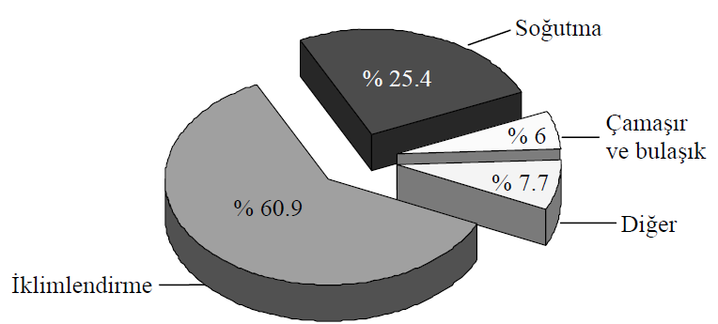
Figure 2.1.Distribution of Domestic Appliances
Source: Sudhaman & Thangavel, 2015

Table 2.1. Product Properties
Product | Price | Time | Weight
R404A | 0.98 | 54 | 1.25
R134A | 1.85 | 45 | 0.987
R407C | 3.54 | 21 | 0.874
Source: Sudhaman & Thangavel, 2015

Quotations
For quotations with less than 40 words
“For quotations with less than 40 words, mark with double-quote within the text and write the whole paragraph with 1,5 line spacing (Author Surname, YEAR, p. PAGE NO).

For quotations with more than 40 words
Longer quotations surpassing 40 words should be removed from the text. The whole text should have a 0,5 cm indentation from left and right with 2 line space. It should be written with 12 punto. These quotations are also called Block Quotations. For block quotations, there is no need for quotation marks. Quotations should be the same as the original, and their sources should be given entirely. (Berktay, 1987).

For the new page, use Insert Page Break, not Enter.

CONCLUSION AND PROPOSALS

BIBLIOGRAPHY

Beck, C. A. J. & Sales, B. D. (2001). Family mediation: Facts, myhts, and future prospects. American Psychological Association.
Çelebi, N. (Ed.). (1990). Kadınlarımızın cinsiyet rolü tutumları. Sebat Yayınları.
Ekşi, H. (2006). Bilişsel ahlak gelişimi kuramı: Kohlberg ve sonrası. Abant İzzet Baysal Üniversitesi Eğitim Fakültesi Dergisi, 6(1), 29-38.
Eyim, A. (2006). Universiter yapıda bilimsel özgürlük ve yönetsel özerkliğin yeri ve önemine sosyolojik bir bakış. R. Yıldız (Ed.). Sosyal Bilimler Eğitimi Kongresi içinde (s.52-64). Yüzüncü Yıl Üniversitesi
Gibbs, J. T., & Huang, L. N. (Eds.). (1991). Children of color: Psychological interventions with minority youth. Jossey-Bass.
Gökbulut, R. İ. (2009). Hissedar değeri ile finansal performans ölçütleri ilişkisi ve İMKB üzerine bir araştırma [Doktora tezi, İstanbul Üniversitesi]
Jenson, E. (2006). Beyin uyumlu öğrenme (A. Doğanay, Çev.). Nobel Yayınevi. (Orijinal baskı, 1999).
Karadağ, E. & Öney, A. (2006). İlköğretim birinci kademesinde portfolyo dosyalarının değerlendirme aracı olarak kullanılabilirliği. Ahi Evran Üniversitesi Kırşehir Eğitim Fakültesi Dergisi, 7(2), 235-246.
Tekeli, Ş. (1995). 1980’ler Türkiye’sinde kadın bakış açısından kadınlar. İletişim Yayınları.

APPENDIX
APPENDIX-1: Examples of Titles

EXAMPLE OF A PRELIMINARY TITLE
(Select the titles in the home section one by one and examine the styles.)
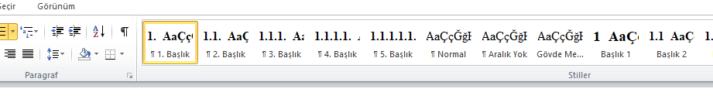

Example of a Second Type Heading
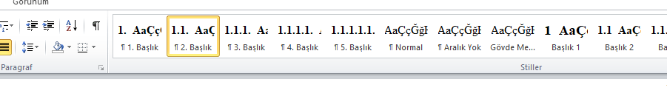

Example of a Third Type Heading
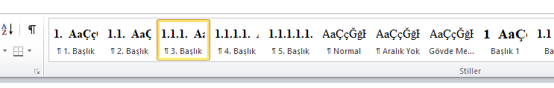

Example of a Fourth Type Heading
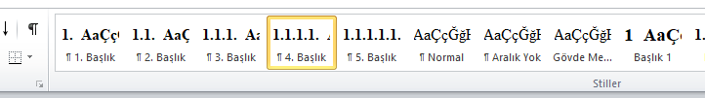

Example of a Fifth Type Heading
